ECG Circuit

*Final Project - Bioelectronics (SBE3130)*

**Done by:**

**St: Asmaa Ibrahim Anwar Sec: 1 BN: 12**

**St: Alaa Moselhy Farag Sec: 1 BN: 13**

**St: Abdelrahman Khaled Ismail Sec: 1 BN: 50**

**St: Mostafa Medhat Hakim Sec: 2 BN: 32**

**St: Mohab Hesham Ahmed Sec: 2 BN: 34**

**St: Hesham Gamal Abdelhady Sec: 2 BN: 46**

We designed a prototype circuit for an ECG in order to assess how the heart is functioning and can be used to diagnose a variety of cardiac diseases. It turns out that an ECG is very easily obtained with a few common circuit components, we use the following components to build our circuit:

1. **Hardware components**

|  |  |  |
| --- | --- | --- |
| Component | Value | Quantity |
| Op Amplifier | “TL084CN” | 1 |
| Capacitors | $$22 nF$$ $$100 μF$$ | 1  2 |
| Resistor | $$10 kΩ$$ $$1 kΩ$$ $$9 kΩ$$ $$100 kΩ$$ $$2 kΩ$$ $$5 kΩ$$ $$90.0 kΩ$$ | 3  2  2  1  1  1  1 |
| Electrodes |  | 3 |
| Crocodile probes |  | 3 |
| Jumpers |  | 1 |

1. **ECG main circuit:**

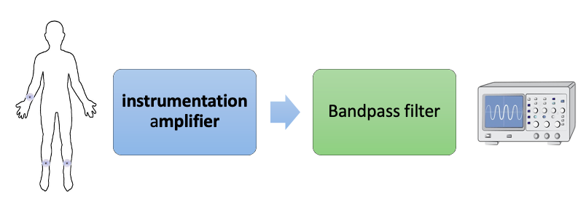

**(HPF + LPF)**

1. **Circuit description:**

Our circuit mainly depends on “TL084CN” op amp. as it can replace the 4 amplifiers that we need in our circuit:

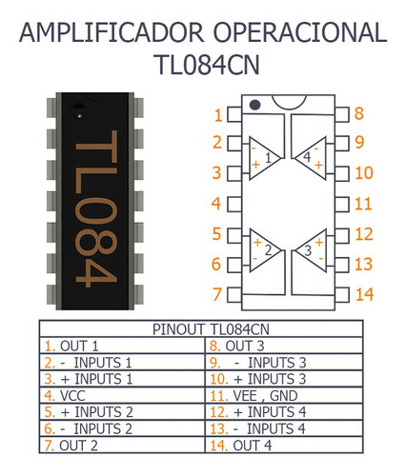

* 1. **instrumentation amplifier:**

The fundamental component of an ECG is the instrumentation amplifier which probably the hallmark amplifier for bioelectrical measurements for a number of reasons, most notably: (1) high input impedance and (2) very good common mode rejection. then it is responsible for taking the voltage difference between leads and amplifying the signal.

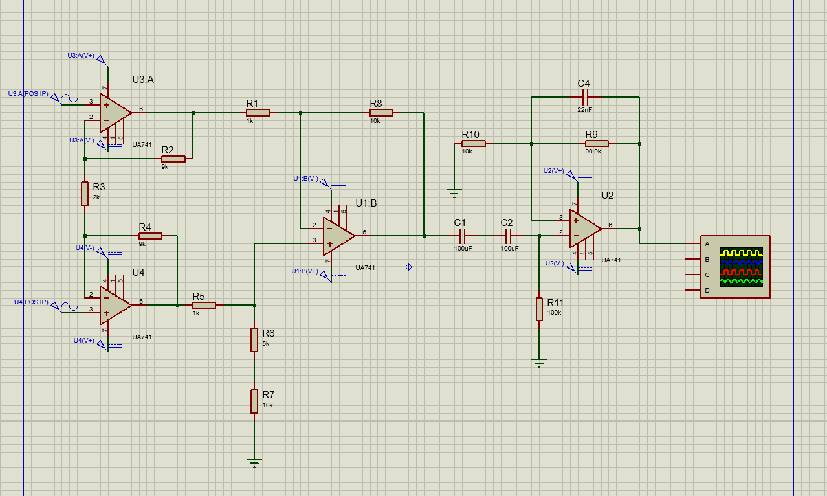It’s basically built from 3 amplifiers and resistors, then first 3 amp in TL084CN amp are used to build the instrumentation amp.

* 1. **Band-pass filter**

A bandpass filter which combines from high and low pass filters only allows those frequencies within a certain band around (0.03~80 Hz) to pass through(Our ECG signal). It’s built from an amplifier, resistors and capacitors.



1. **Limitations:**

We used just one lead (lead II) and 3 electrodes. Also we used a band-pass filter not high-pass filter, so normal ECGs only will be displayed on this circuit.

Lead II: one of limb leads. ﻿Lead II is the voltage difference between the left leg (LL) electrode and the right arm (RA) electrode.

**Finally, we got our ECG circuit:**



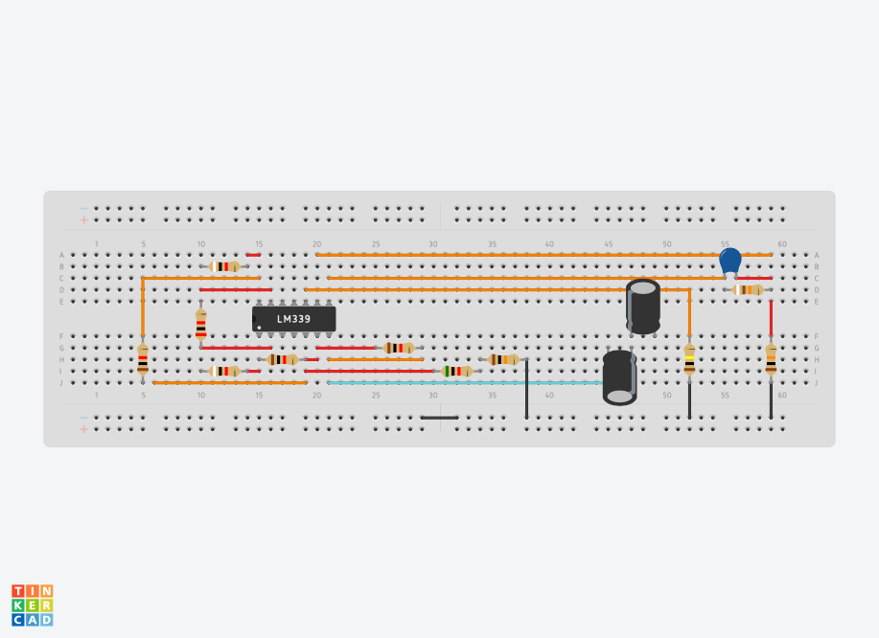

**TL084**

**The output:**

1. 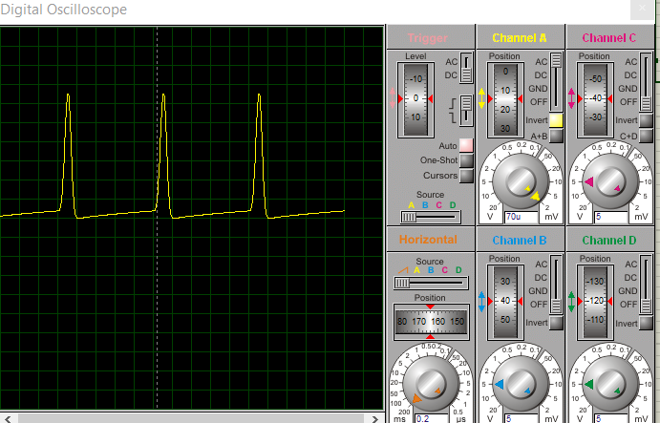**Using Proteus**
2. **In lab**

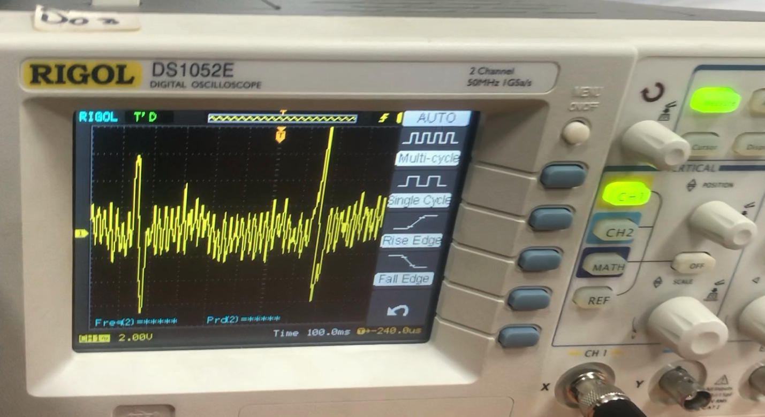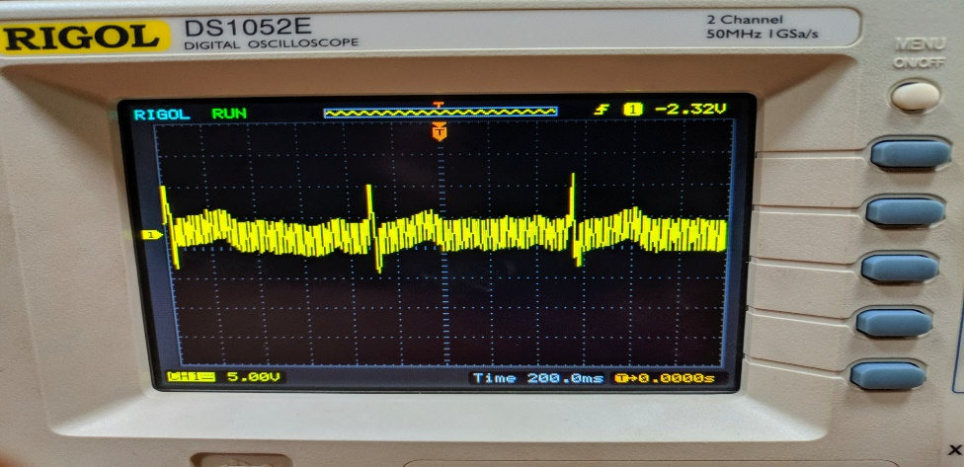

**Another Scale:**